**Output:**

**OS Detection**

**1.Ip address of 192.168.0.1**

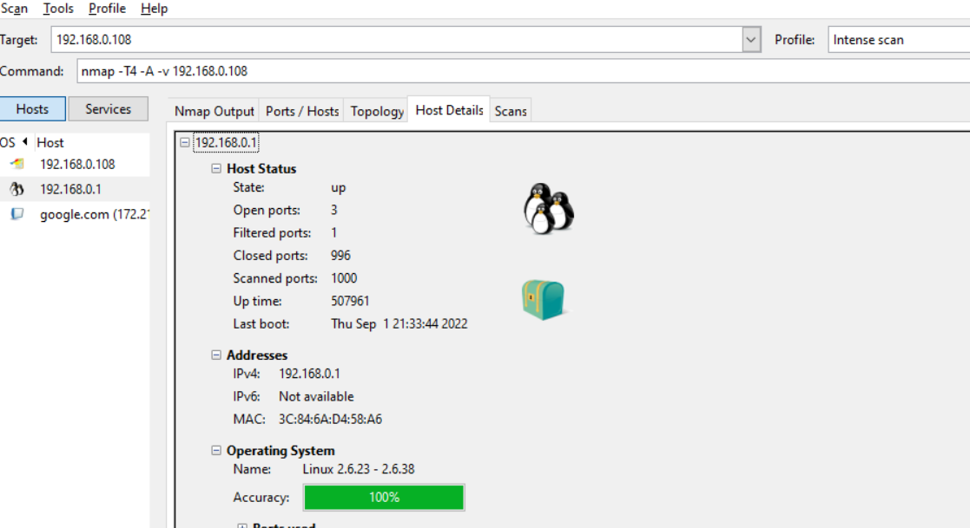

**2.IP Address 192.168.0.108**

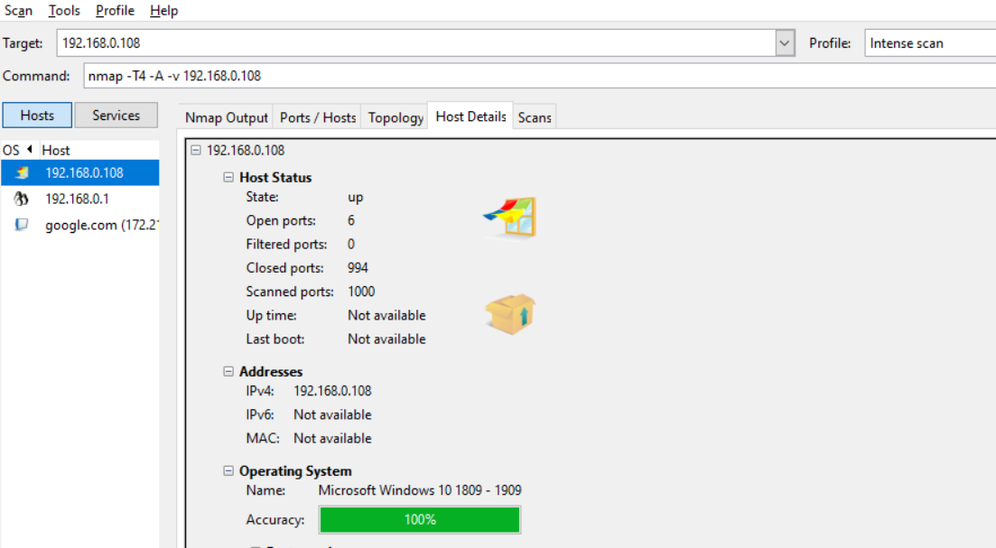

**3.Google.com**

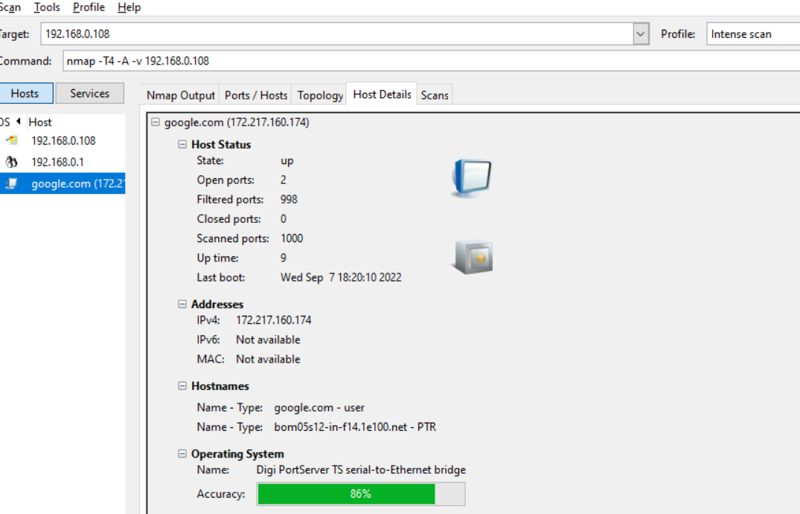

**Information About Target**

**1. Google.com**

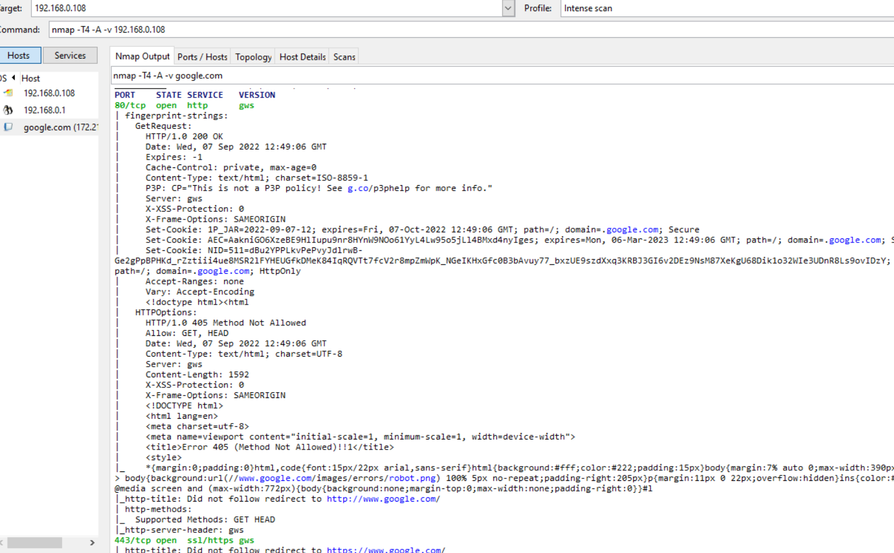

**2. IP Address 192.168.0.108**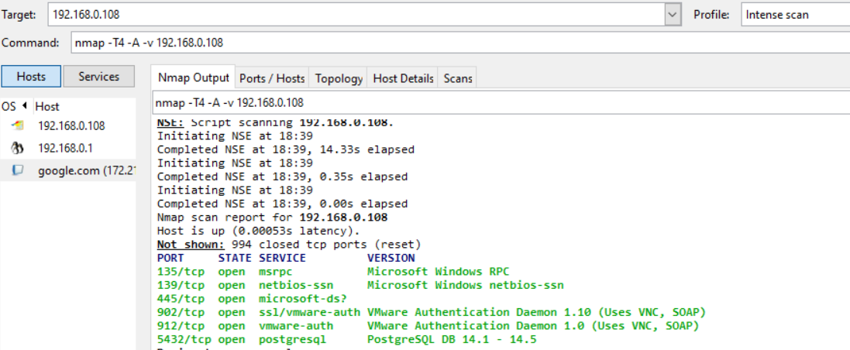

**3. IP address of 192.168.0.1**